Lab 8: Voltage-to-Frequency Converters

Historically, voltage-to-frequency (V-F) converters were used as the input stage for digital recorders. A slowly varying input analog signal was converted into a frequency, then recorded on a conventional magnetic tape recorder. This combination provided a high precision analog recorder, whose output was a digital frequency. More recently, V-F converters are found in the front end of inexpensive digital voltmeters, and other low cost analog-to-digital circuits. The classic 555-timer chip studied in chapter 7 is a form of voltage-to-frequency converter.

The heart of a V-F converter is an integrating op-amp circuit. The input voltage is connected to the integrator, which ramps up to a preset voltage level. At this upper limit, the input is replaced with a reference input, but of the opposite polarity, and the output integrates down to a lower limit. At this limit, the reference input is removed and the input signal reconnected. The oscillator cycle begins again. The output is a logic low during signal integration, and a logic high during reference integration. The resulting waveform has constant on-time, and a variable off-time, proportional to the magnitude of the input signal. The output frequency is proportional to the input signal level.

A V-F converter consists of four fundamental op-amp building blocks: an electronic switch, an integrator, a comparator and a monostable.

Figure 8-1 The building blocks of a Voltage-to-Frequency Converter

The input V_{in} (usually a negative voltage) is ramped up by the op-amp integrator. In the following example, the output rises from -10 volts towards 0 volts. An op-amp comparator is referenced at zero volts. At this upper limit, it switches from a high state to a low state creating a negative going pulse used to trigger the next stage, a 555 monostable. Once triggered, the output of the monostable (a positive voltage) replaces the input voltage. The integrator now ramps down until the monostable has timed out. The monstable voltage is replaced with the input signal and the cycle begins again.

In the following diagram, the input voltage is - 5 volts. The upper reference level is 0 volts and the lower reference level is set by the monostable on-time. The capacitor voltage is shown as the heavy (red) trace. The monstable output goes from 0 to 5 volts (yellow trace). The comparator output is seem as the light line (green trace) which goes from +15 to -15 and back to +15 volts.

Figure 8-2 LabVIEW Display of the V-F Timing Diagrams

Reducing the input signal lowers the charging rate (slope of the heavy line), increasing the period and decreasing the frequency.

Block 1: The Op-Amp Integrator
When a capacitor is placed in the feedback loop of a conventional inverting op-amp circuit, the result is that the summing current is accumulated on the capacitor. The output voltage thus becomes the sum of all the input charges.
Figure 8-3 Op-Amp Integrator Circuit

From lab 2, you will recall that the output voltage is the integral of the input voltage scaled by the charging time constant RC.
Vout = - 1/RC ∫Vin dt Equation 8.1

If the input voltage is a constant and negative, the output voltage becomes a ramp increasing linearly until the output reaches the positive rail voltage. If you reverse the input voltage, the op-amp integrates downwards linearly until it reaches the negative rail. The ramp output is just

Vout = - (Vin/RC) t Equation 8.2

In order to simulate the operation of the V-F circuit, time is divided into time slices and the differential form of the above equation is used to calculate the output voltage V'out at the end of each time slice:
V'out = Vout - (Vin/RC) Δ t Equation 8.2
where Vout is the voltage at the start of the time slice and Δt is the size of the time slice.

LabVIEW Demo 8.1: Operation of an Op-Amp Integrator
Load the program called Integrator1.vi from the chapter 8 library. This program simulates the dynamic operation of an op-amp using equation 3. Each time you click on [Run], a new output voltage is calculated and displayed on a chart (capacitor voltage versus time). Initially the output voltage is set to -3 volts. With Vin = -5 volts, R = 150 kΩ and C= 0.1μf, the incremental voltage will be 0.333 V for a 1 millisecond time slice. Click the run button a few times so you can see the ramping voltage. At any time, you can change Vin, R or C to modify the rate of change (the slope of the ramp). In fact if you change the sign of the input, the output voltage will ramp down.
Try clicking on the run button 10 times. Then change the sign of the input voltage. Again click the run button 10 times. What kind of waveform have you just generated?

LabVIEW Project A real op-amp integrator
Use a real op-amp (741) to build the integrator circuit below.

Figure 8-4 Op-Amp Intetgrator Circuit with manual Reset

Apply a 2 volt P-P, 100 kHz square wave to the input. Observe both the input and output signals on a dual channel oscilloscope or DAQ card.

Observe what happens if the signal amplitude becomes too large.

What happens when the frequency becomes too small at a constant amplitude.

What do you think will happen if the input signal is a triangular waveform? Try it!

Block 2: Comparator
An op-amp with no input resistor and no feedback resistor becomes a comparator. If the signal on the summing input (-) is larger than the non-inverting input (+), then the output swings to the maximum negative voltage. If the signal at the summing input is smaller than the non-inverting input, then the output swings to the maximum positive voltage. The speed of the change from one rail to the other is related to the open loop gain and is called the slew rate. By connecting a reference voltage (V_{ref}) to one of the inputs, a trigger level can be defined at Vref and a negative-going output will signal when the input voltage is larger than the reference voltage.

Figure 8-5 Op-Amp Comparator Circuit

LabVIEW Demo 8.2: Op-Amp Comparator in Action
Load the program called Comparator1.vi from the chapter 8 library. Run the program and observe that the comparator output can only be at one or the other rail voltage. In the V-F circuit, the reference voltage will be taken as zero volts. Modify the reference voltage to this value and run the VI again.

LabVIEW Demo 8.3: Op-Amp Integrator and Comparator in Series
Load the program called Integrator2.vi from the chapter 8 library. Each time you click on [Run], a new output voltage is calculated. Initially the integrator voltage is set to -3 volts. As before with Vin = -5 volts, R = 150 kΩ and C= 0.1μf, the incremental voltage for each 1 millisecond time slice will be 0.333 V. Watch the comparator output when the integrator reaches the reference voltage at zero volts. Continue clicking until the integrator output reaches + 3 volts. Now reverse the input voltage to +5 volts and integrate down through the reference voltage until the integrator output is - 3 volts. Repeat the cycle (Vin = -5 v, 10 clicks; Vin = +5 v, 10 clicks) once more. The sign of the comparator output signals when the input is positive or negative. Notice that the comparator changes state or is toggled each time the integrator level crosses zero volts. In this mode, the comparator is a zero crossing detector. Notice the waveform produced on the integrator and comparator outputs.
In the V-F circuit, the reference voltage will be set to zero volts (upper limit) and the lower limit (initial voltage) will be set to some negative voltage.

Block 3: The Monostable

Recall from Lab 7 that when a 555 monostable is triggered, the output goes high for a period of time set by an external resistor and capacitor. The on-time is 1.1 RC. Setting R = 36 kΩ and C = 0.1 μf yields an on-time of 3.96 milliseconds. The monostable needs a falling edge to trigger the circuit, followed by a rising edge. This is accomplished in the real V-F circuit using a resistor-diode network consisting of a 1.5 kΩ resistor and two 1N914 diodes used to clamp the trigger voltage within the 555's input range.

Figure 8-6 555 Monostable Circuit

The monstable output when high will be close to the positive power supply voltage and will be used to forward bias a third 1N914 silicon diode shown in the next section. A high output allows current to pass through an 0.5 kΩ output resistor to ground. From Ohm's law, this current will be (15.0 V-0.6 V)/0.5 kΩ = 28.8 ma.

LabVIEW Demo8.4: Monostable Operation
Load the program called Monostable.vi from the chapter 8 program library. Click on the [Run] button to activate the circuit and click on the trigger switch to trigger the monostable.

Figure 8-7 LabVIEW Simulation – Monostable Circuit as a Current Driver

Note that current only flows through the resistor when the monostable is triggered. The magnitude of the current can be adjusted with the choice of the resistor.

Question: Suppose the above current was used as the input to the integrator, how long would it take the integrator voltage to reach -10 volts assuming that the output voltage was initially 0 volts? The answer is contained in equation (8-3)

V'out = Vout - (iin/C) Δt or -10 = 0 - (28.8 ma/0.1μf) Δt Equation 8.4
Δt = 34.7 microseconds Equation 8.5

Part 4: A Real V-F Converter

The output of the monostable is used in a real V-F converter circuit to generate a reset current for the integrator. When the diode is forward biased by the monostable, a reset current is applied to the summing point of the integrator. Since the monostable current is much larger than the input current, the summing point becomes the switch and the integrator is ramped down for a time defined by 1.1RC. When the monostable shuts off, the input current dominates and the integrator output ramps up to 0 volts. Here the monstable resets and the cycle starts again. The period as seen on the monostable output is related to the input voltage level. When the monostable on-time is short, the frequency is directly proportional to the input voltage, a true V-F converter.

Figure 8-8 555 Schematic Diagram for a Real V-F Converter Circuit

LabVIEW Demo 5: Operation of the V-F Circuit
Load the program called VF.vi from the chapter 8 program library, VF.llb . Click on the [Run] button and investigate the variation of the period with the input level. When the action is stopped, the magnifying cursor can be used to expand the time to see a close up of the complete timing diagram.

Figure 8-9 V-F Timing Diagrams

When the monostable is off, the input signal (red trace) ramps up until the integrator output reaches the comparator trigger level at zero volts. The comparator (green trace) flips to the opposite rail generating a trigger signal for the monostable which in turn (yellow trace) generates a reset current that is much larger than the input signal and of opposite sign. The integrator ramps down towards a negative voltage. As soon as the integrator voltage reaches zero volts, the comparator flips back to its initial state (+15 V). At the end of the monostable timing period, the reset current is returned to zero and the integrator ramps up again driven by the input signal level.

LabVIEW Exercise: Plot the output frequency versus input voltage.

eLab Project 8

Objective: To study the operation of a Voltage-to-Frequency converter circuit built from basic analog chips, the op-amp and the 555 timer.

Procedure: Build a voltage-to-frequency converter circuit using the schematic diagram of figure 8.8. It requires four resistors, two capacitors, three silicon diodes, two op-amps and one 555 timer IC. The chip pinouts can be found in Lab 1, figure 1-5 and Lab 6, figure 6-1. The op-amps and timer chips are powered from +15 and –15 volt power supplies. The circuit requires that the integrator be in a known state (a negative or zero voltage on the input) for the feedback to work correctly. This is easily set be momentarily shorting the integrator capacitor. After started the circuit will run until the power is removed. The component layout is shown below.

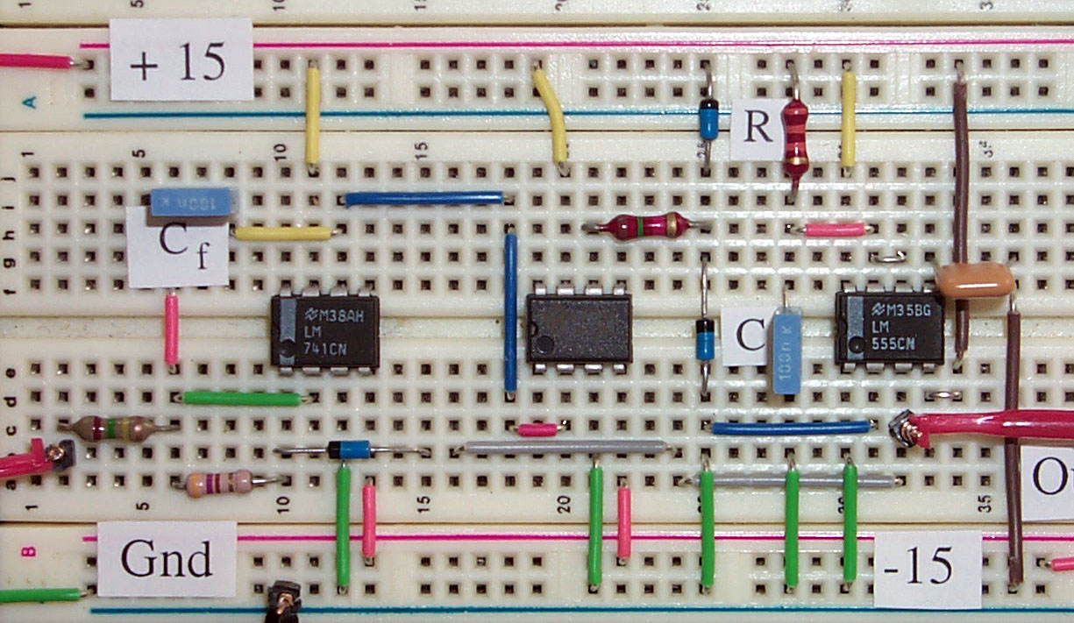

Figure 8-10 V-F Component Layout

Plot the V-F output frequency as the input voltage in varied from –5 to - 0.5 volts.

Computer Automation 8 : V-F Calibration Curve

Computer Automation implies the repetitive measurement of circuit parameters and the analysis and reporting of that data set. In this lab, a system test for the V-F circuit of eLab 8 is presented. The operator will be able to set a range of test input signals and the number of tests to be run. In operation, a test voltage is output on one pin of the DAQ card which is to be connect to the input of the V-F circuit. The V-F output can be connected to a counter input pin of the DAQ card and using Frequency.vi, introduce in computer automation lab 6, the frequency of the V-F circuit measured. After all data points are collected, the V-F calibration curve is displayed on the front panel.

LabVIEW Design

A starting design for a LabVIEW test program, called V-F Scan.vi is found in the program library. Launch this program and open up the diagram window. Notice that two subVIs, Write1pt.vi and Frequency.vi are used. Write1pt.vi is a subVI used in earlier labs to generate a test voltage on the analogout pin [device1/channel0]. Connect this pin to the input lead of the eLab V-F circuit. Frequency.vi is similar to FrequencyLow.vi introduced in the computer automation lab 6, but modified so that it can be used as a subVI. Connect the output of the eLab V-F circuit to counter2 clk input pin of your DAQ card. Select the start and stop voltage levels and the number of points to acquire for the calibration curve. When all wires are connected and the V-F circuit is operating, click on [Run]. Each input voltage level and measured frequency will be displayed as it is measured. After all n points have been acquired, the calibration curve will appear in the graph display.

LabVIEW Enhancements

Design a LabVIEW program that fits a polynomial curve to your measured calibration curve and displays the polynomial coefficients.

